Exploring Cisco NSO APIs.

We will first find the URLs. It will return the all the paths.
curl -X GET \
"http://10.10.20.47:8080/restconf/data/devices/device=core-rtr01" \
-u "developer:C1sco12345" \
-H "Accept: application/yang-data+json"
The response will be hugh so we can use depth=1 to find the paths.
curl -X GET "http://10.10.20.47:8080/restconf/data/devices/device=core-rtr01?depth=1" -u "developer:C1sco12345" -H "Accept: application/yang-data+json"
{
"tailf-ncs:device": [
{
"name": "core-rtr01",
"created": "2025-04-30T11:36:00.001678+00:00",
"last-modified": "2026-01-15T04:47:51.36521+00:00",
"last-connected": "2026-01-15T05:04:33.884092+00:00",
"last-in-sync": "2026-01-15T04:47:51.372525+00:00",
"address": "10.10.20.173",
"ssh": {
},
"authgroup": "labadmin",
"device-type": {
},
"commit-queue": {
},
"active-settings": {
},
"state": {
},
"platform": {
},
"config": {
},
"live-status": {
},
"tailf-ncs-alarms:alarm-summary": {
}
}
]

Now we can call these path example state and see what inside the state we will construct the url.

curl -X GET "http://10.10.20.47:8080/restconf/data/devices/device=core-rtr01/state" -u "developer:C1sco12345" -H "Accept: application/yang-data+json"

response:

{
"tailf-ncs:state": {
"oper-state": "enabled",
"transaction-mode": "ned",
"last-transaction-id": "1000000011+10007",
"admin-state": "unlocked"
}
}

Now we will explore the config. We did the depth=1 and find the url path and we go more deeper we find the configuration parameters that will help us to get the router configuration.

imi_z@Imran:~$ curl -X GET "http://10.10.20.47:8080/restconf/data/devices/device=core-rtr01/config?depth=1" -u "developer:C1sco12345" -H "Accept: application/yang-data+json"
{
"tailf-ncs:config": {
}
}
imi_z@Imran:~$ curl -X GET "http://10.10.20.47:8080/restconf/data/devices/device=core-rtr01/config?depth=2" -u "developer:C1sco12345" -H "Accept: application/yang-data+json"
{
"tailf-ncs:config": {
"tailf-ned-cisco-ios-xr:admin": {
},
"tailf-ned-cisco-ios-xr:hostname": "core-rtr01",
"tailf-ned-cisco-ios-xr:vrf": {
},
"tailf-ned-cisco-ios-xr:logging": {
},
"tailf-ned-cisco-ios-xr:service": {
},
"tailf-ned-cisco-ios-xr:domain": {
},
"tailf-ned-cisco-ios-xr:telnet": {
},
"tailf-ned-cisco-ios-xr:username": [
],
"tailf-ned-cisco-ios-xr:line": {
},
"tailf-ned-cisco-ios-xr:vty-pool": {
},
"tailf-ned-cisco-ios-xr:control-plane": {
},
"tailf-ned-cisco-ios-xr:ssh": {
},
"tailf-ned-cisco-ios-xr:interface": {
},
"tailf-ned-cisco-ios-xr:router": {
},
"tailf-ned-cisco-ios-xr:call-home": {
},
"tailf-ned-cisco-ios-xr:xyzroot": 0,
"ietf-yang-library:yang-library": {
},
"ietf-yang-library:modules-state": {
}
}
}

Now we construct the url and the response back.

curl -X GET \
-u "developer:C1sco12345" \
-H "Accept: application/yang-data+json" \
"http://10.10.20.47:8080/restconf/data/devices/device=core-rtr01/config/router"

{
"tailf-ned-cisco-ios-xr:router": {
"static": {
"address-family": {
"ipv4": {
"unicast": {
"routes-ip": [
{
"net": "0.0.0.0/0",
"address": "172.16.253.4"
}
]
}
}
},
"vrf": [
{
"name": "Mgmt-intf",
"address-family": {
"ipv4": {
"unicast": {
"routes-ip": [
{
"net": "0.0.0.0/0",
"address": "10.10.20.254"
}
]
}
}
}
}
]
},
"ospf": [
{
"name": "1",
"area": [
{
"id": 0,
"interface": [
{
"name": "GigabitEthernet0/0/0/0"
},
{
"name": "GigabitEthernet0/0/0/1"
}
]
}
]
}
]
}
}

We login into the router made changes

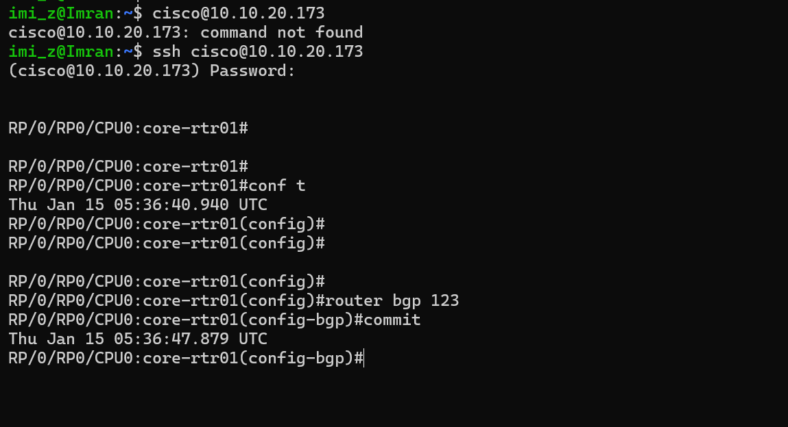

Key Point: We called the url again the response didn’t return show the bgp configuration, why the NSO is query cdb database, and configuration done from the CLI and configuration between the NSO and router OUT of SYNC.

curl -X GET -u "developer:C1sco12345" -H "Accept: application/yang-data+json" "http://10.10.20.47:8080/restconf/data/devices/device=core-rtr01/config/router"
{
"tailf-ned-cisco-ios-xr:router": {
"static": {
"address-family": {
"ipv4": {
"unicast": {
"routes-ip": [
{
"net": "0.0.0.0/0",
"address": "172.16.253.4"
}
]
}
}
},
"vrf": [
{
"name": "Mgmt-intf",
"address-family": {
"ipv4": {
"unicast": {
"routes-ip": [
{
"net": "0.0.0.0/0",
"address": "10.10.20.254"
}
]
}
}
}
}
]
},
"ospf": [
{
"name": "1",
"area": [
{
"id": 0,
"interface": [
{
"name": "GigabitEthernet0/0/0/0"
},
{
"name": "GigabitEthernet0/0/0/1"
}
]
}
]
}
]
}
}

The solution for this problem is to call another api syn from

curl -X POST \
"http://10.10.20.47:8080/restconf/data/devices/device=core-rtr01/sync-from" \
-u "developer:C1sco12345" \
-H "Accept: application/yang-data+json"

{
"tailf-ncs:output": {
"result": true
}
}

Action | Method | URL
Sync from device | POST | /devices/device=core-rtr01/sync-from
Sync to device | POST | /devices/device=core-rtr01/sync-to
Compare config | POST | /devices/device=core-rtr01/compare-config
Check sync | POST | /devices/device=core-rtr01/check-sync

curl -X GET -u "developer:C1sco12345" -H "Accept: application/yang-data+json" "http://10.10.20.47:8080/restconf/data/devices/device=core-rtr01/config/router"

{
"tailf-ned-cisco-ios-xr:router": {
"static": {
"address-family": {
"ipv4": {
"unicast": {
"routes-ip": [
{
"net": "0.0.0.0/0",
"address": "172.16.253.4"
}
]
}
}
},
"vrf": [
{
"name": "Mgmt-intf",
"address-family": {
"ipv4": {
"unicast": {
"routes-ip": [
{
"net": "0.0.0.0/0",
"address": "10.10.20.254"
}
]
}
}
}
}
]
},
"ospf": [
{
"name": "1",
"area": [
{
"id": 0,
"interface": [
{
"name": "GigabitEthernet0/0/0/0"
},
{
"name": "GigabitEthernet0/0/0/1"
}
]
}
]
}
],
"bgp": {
"bgp-no-instance": [
{
"id": 123
}
]
}
}
}

We can call all the below options in API calls
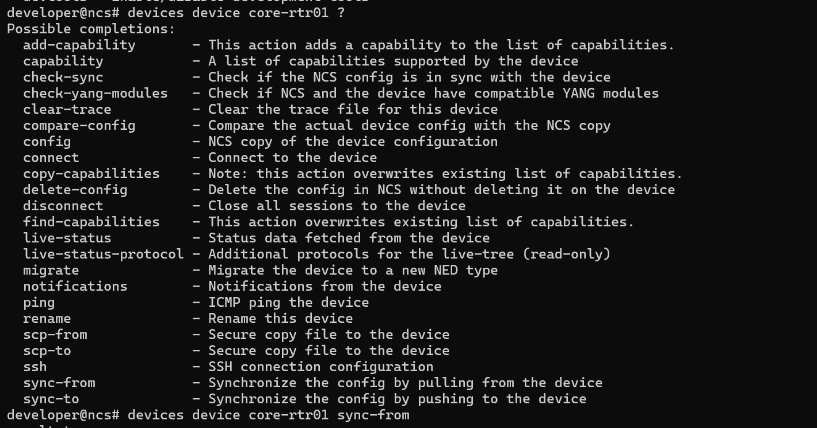

Below is the API to get the live data from the devices.

curl -X POST \
"http://10.10.20.47:8080/restconf/data/devices/device=core-rtr01/live-status/tailf-ned-cisco-ios-xr-stats:exec/any" \
-u "developer:C1sco12345" \
-H "Content-Type: application/yang-data+json" \
-H "Accept: application/yang-data+json" \
-d '{"input": {"args": ["show interfaces brief"]}}'

Response:

{
"tailf-ned-cisco-ios-xr-stats:output": {
"result": "\r\n\rThu Jan 15 05:59:58.911 UTC\r\n\r\n Intf Intf LineP Encap MTU BW\r\n Name State State Type (byte) (Kbps)\r\n--------------------------------------------------------------------------------\r\n Lo0 up up Loopback 1500 0\r\n Nu0 up up Null 1500 0\r\n Mg0/RP0/CPU0/0 up up ARPA 1514 0\r\n Gi0/0/0/0 up up ARPA 1514 1000000\r\n Gi0/0/0/1 up up ARPA 1514 1000000\r\n\r\nRP/0/RP0/CPU0:core-rtr01#"
}
}

Converting the xpath to url the below are the xpath routing protocol

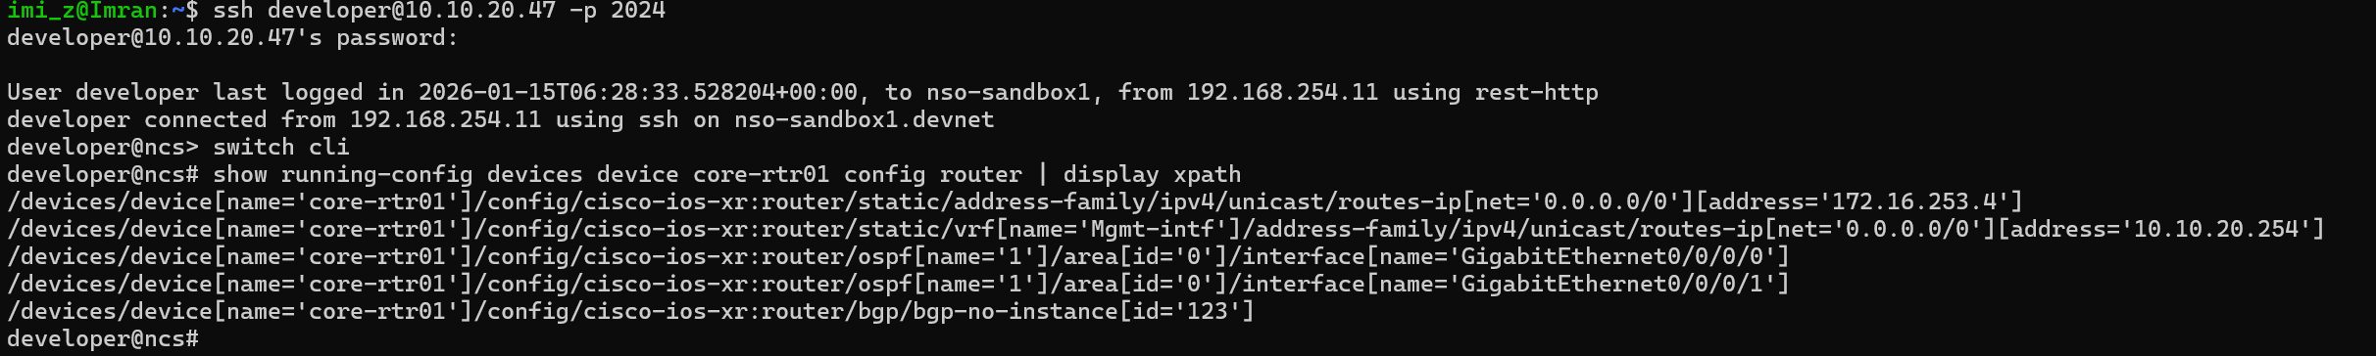

developer@ncs> switch cli
# show running-config devices device core-rtr01 config router | display xpath

/devices/device[name='core-rtr01']/config/cisco-ios-xr:router/static/address-family/ipv4/unicast/routes-ip[net='0.0.0.0/0'][address='172.16.253.4']
/devices/device[name='core-rtr01']/config/cisco-ios-xr:router/static/vrf[name='Mgmt-intf']/address-family/ipv4/unicast/routes-ip[net='0.0.0.0/0'][address='10.10.20.254']
/devices/device[name='core-rtr01']/config/cisco-ios-xr:router/ospf[name='1']/area[id='0']/interface[name='GigabitEthernet0/0/0/0']
/devices/device[name='core-rtr01']/config/cisco-ios-xr:router/ospf[name='1']/area[id='0']/interface[name='GigabitEthernet0/0/0/1']
/devices/device[name='core-rtr01']/config/cisco-ios-xr:router/bgp/bgp-no-instance[id='123']

Assume we want to get the static routing information what we did

Xpath: devices/device[name='core-rtr01']/config/cisco-ios-xr:router/static/address-family/ipv4/unicast/ convert this to restconfig url

Restconf: devices/device=core-rtr01/config/cisco-ios-xr:router/static/address-family/ipv4/unicast/

curl -X GET \
-u "developer:C1sco12345" \
-H "Accept: application/yang-data+json" \
http://10.10.20.47:8080/restconf/data/devices/device=core-rtr01/config/tailf-ned-cisco-ios-xr:router/static/address-family/ipv4/unicast

response

{
"tailf-ned-cisco-ios-xr:unicast": {
"routes-ip": [
{
"net": "0.0.0.0/0",
"address": "172.16.253.4"
}
]
}
}

